**NAIVE BAYES**

Bayes Theorem

Let there be 2 machines, m1 and m2. Both produce wrenches labelled as m1 and m2 respectively.

There are some defected wrenches also.

What is the probability that the wrench is made from machine m2?

-> Concept used: Bayes’ theorem

P(A|B) = (P(B|A) * P(A)) / P(B)

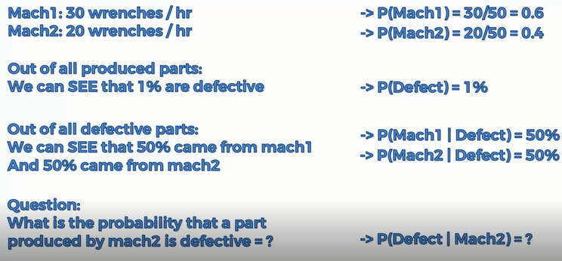



Naive Bayes Classifier

We have a dataset with 2 features(variables) salary and age and 2 categories red and green.

What if we add a new data point to this dataset? How to classify this new data point?

-> For this the following steps are used:

Calculate:

STEP 1 P(Walks|X)

STEP 2 P(Drives|X)

STEP 3 P(Walks|S) v/s P(Drives|X)

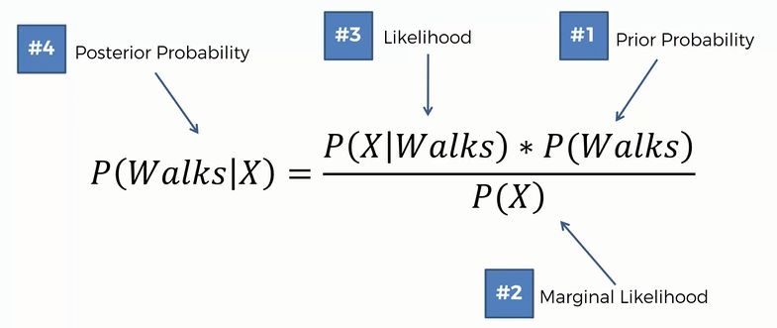

P(Walks) = No. Of walks / Total observations

For P(X) we first draw a circle of any radius around our new data point in our dataset.

P(X) = No. Of similar observations / Total observations

For P(X|Walks) draw the same circle again

P(X|Walks) = (No. Of similar oservations among those who walk) / Total number of walks

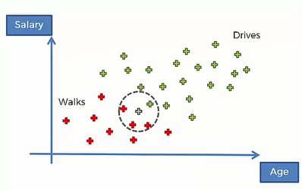

Similarly, P(Drives|X) is calculated and then P(Walks|S) and P(Drives|X) are compared. The one which has higher probability to that class the new data point is assigned.

[There is an assumption: Independence assumption, for example age and salary have to be independent.]